**ORDER PROCESSING SYSTEM**

*A Project Report Submitted in the Fulfillment of the Requirements.*

***Submitted By:***

**Team:** BC_PUN_2_TEAM 3

**Team Name:** CODE CRAFTERS

**Team Members:**

ABHISHEK GURURANI

ARUN KUMAR S

ARCHANA RATHORE

ASHISH PATWAL

GARGI

RAMYA DANDU

SAMIKSHA MAHURE

VIDHI SAXENA

**ABSTRACT:**

The Order Processing System project is an efficient and user-friendly system for managing orders. In today's digital age, an online order processing system is essential for modern businesses to ensure streamlined operations, enhanced customer experiences, and data-driven decision-making. This project focuses on building a robust and responsive web-based platform that facilitates the end-to-end order management process. The project leverages web technologies such as HTML, CSS, JavaScript, and JDBC to design and implement.The front-end implementation of the project includes implementation of Employee login interface, Customer login interface and creating new quotes. This implementation is done using HTML, CSS, JavaScript. Whereas the Backend includes implementation of database, handles data processing, and manages interactions between the client and the database. JDBC(Java DataBase Connectivity) is used to create connection.

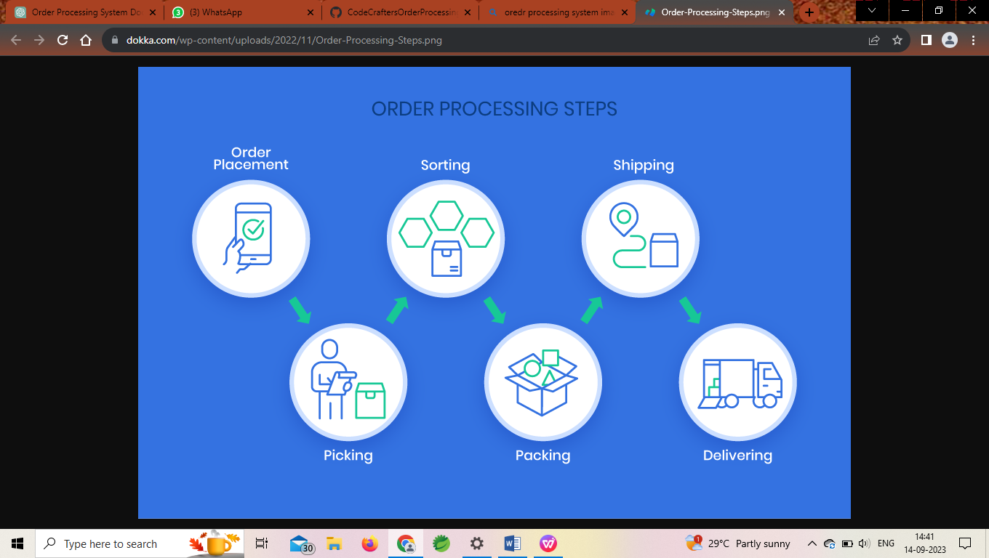

**INTRODUCTION**

An Order Processing System is a critical component of modern business operations, providing a structured and efficient approach to managing customer orders from initiation to fulfillment. It plays a pivotal role in enhancing customer satisfaction, streamlining operations, and ensuring accuracy throughout the order lifecycle.In today's highly competitive business landscape, companies across various industries rely on order processing systems to handle the complexities of their sales and distribution processes. Whether you're in retail, e-commerce, manufacturing, or services, an effective OPS can significantly impact your bottom line and customer relationships. Order Processing System is an indispensable tool for businesses looking to thrive in a fast-paced, customer-centric marketplace. It enables companies to provide seamless order experiences, optimize operations, and gain a competitive edge in today's digital economy.Key Components and Features of an Order Processing System:

1. **Order Creation**: The system allows for the efficient creation of customer orders. This includes capturing order details such as product or service selection, quantity, shipping preferences, and payment information.
2. **Inventory Management:** It maintains an up-to-date inventory of products or services. This helps prevent overselling and ensures that products are available for fulfillment.
3. **Order Validation**: Before processing an order, the system often performs validation checks. This may include verifying product availability, checking customer credit limits and ensuring that the order adheres to company policies.
4. **Order Tracking**: Customers and employees can track the status of orders in real-time. This transparency helps manage customer expectations and reduces the number of inquiries.
5. **Payment Processing:** The system securely processes payments, ensuring that customers are charged accurately. It supports various payment methods, including credit cards, online payment gateways, and invoicing for B2B transactions.
6. **Shipping and Logistics:** It interfaces with shipping carriers and logistics providers to facilitate the delivery process. This includes generating shipping labels, calculating shipping costs, and tracking shipments.
7. **Customer Communication:** The system can automatically send order confirmations, shipping notifications, and invoices to customers via email or other communication channels.
8. **Reporting and Analytics:** It provides valuable insights into sales trends, order volumes, and customer behavior. This data can be used for strategic decision-making and optimizing inventory levels.

**OBJECTIVES**

The primary objective of this project is to design a web-based Order Processing System application that processes orders and generates an invoice. That involves designing Home page in which an employee and customer login pages are developed. Also an Order Management page that displays the employee information, ID, last logged-in details. A list of orders where each list item displays the Order ID, Customer Name, Order Date, Order Value, Customer city, Status. A view invoice button is displayed for approved and completed orders, which allows you to download invoice on clicking the button.

* The main aim of this project is to improve the efficiency of the entire order management process within a business.
* To reduce manual intervention and processing times, resulting in faster order fulfillment and improved customer satisfaction. And to optimize operational processes.
* To minimize errors, discrepancies, and data duplication to enhance customer trust and reduce costly order-related issues.
* To Provide a seamless and user-friendly ordering experience for customers. Offer real-time order tracking, status updates, and communication channels to keep customers informed and engaged.
* To Allow customers to customize their orders as per their preferences, such as selecting product options, quantities, and delivery preferences.
* To Reduce operational costs associated with manual order processing, paperwork, and order-related errors.
* Providing hassle-free ordering process and exceptional service to customers.

**METHODOLOGY**

**FRONT-END FLOW REPRESENTATION**

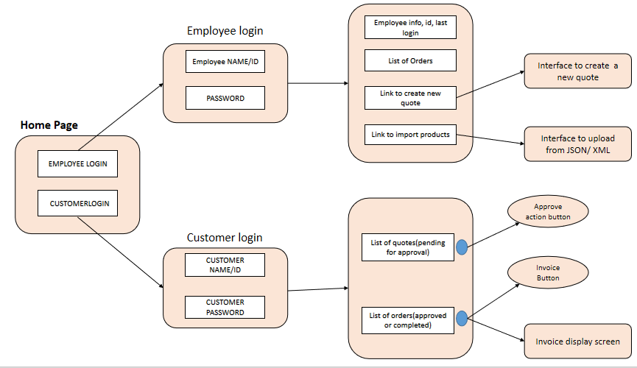

**Home Page:**

The web-application developed firstly opens with a home page. The Home page contains page links for Employee Login and Customer Login and About on the top right corner. The team name is displayed in the center of the Home Page. If the user is Employee, he has to click on Employee Login which directs him to an Employee Login Page. If the user is Customer, then he has to click on Customer Login link that directs him to Customer Login Page. And clicking on About give some extra information.

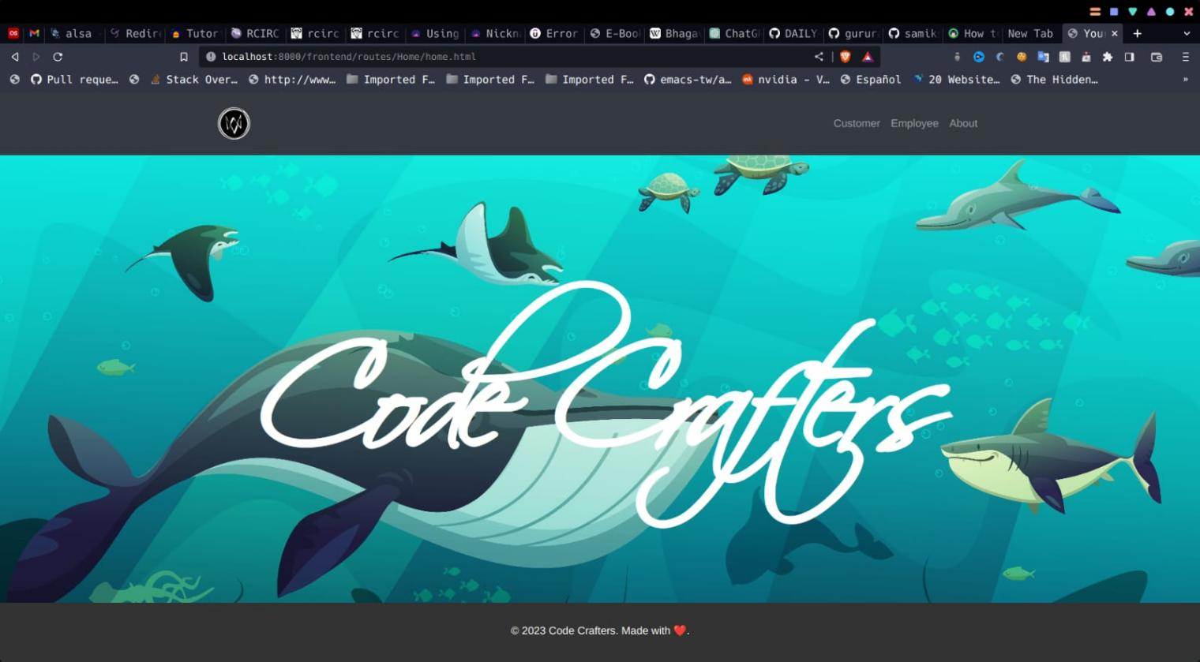

**Employee Login Page:**

Employee Login page is exclusively for employees of the firm. This page displays a form for employees to login. For an employee to login, credentials like Employee ID and Password are asked. On successful login, the employee is directed to the Order Management page.

The Employee Login page is designed using web-technologies like HTML and CSS for styles

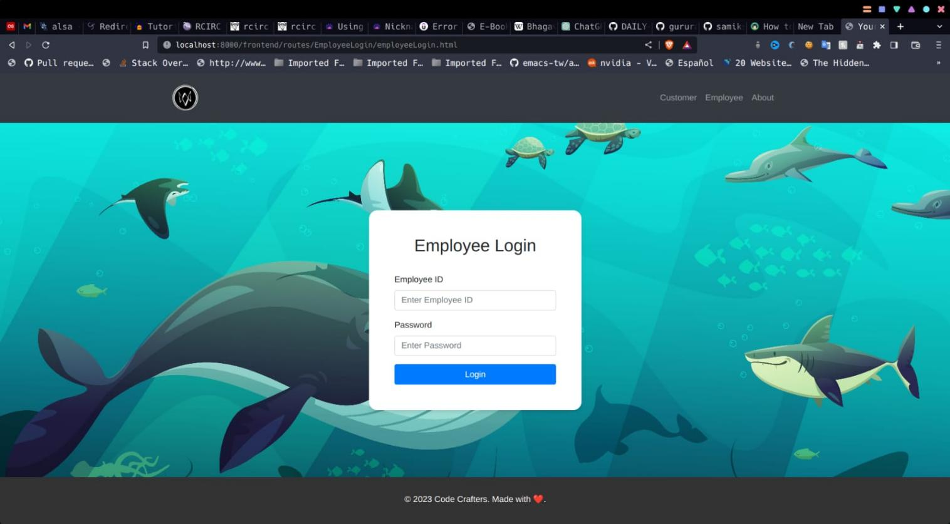

Once the employee login successfully, he is directed to Order Management Page where employee details, ID and last logged-in details are displayed.

And list of orders with each item’s order ID, Customer Name, Order Date, Order Value, Customer City and Status are displayed.

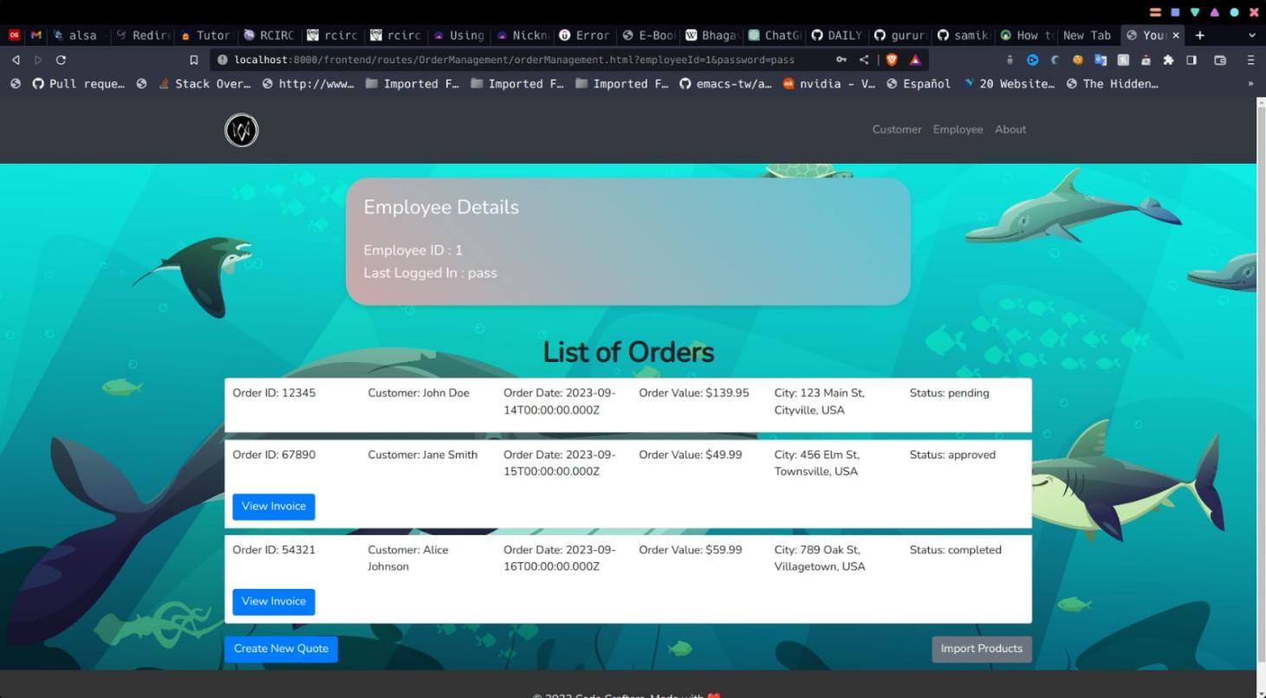

**CREATING NEW QUOTE**

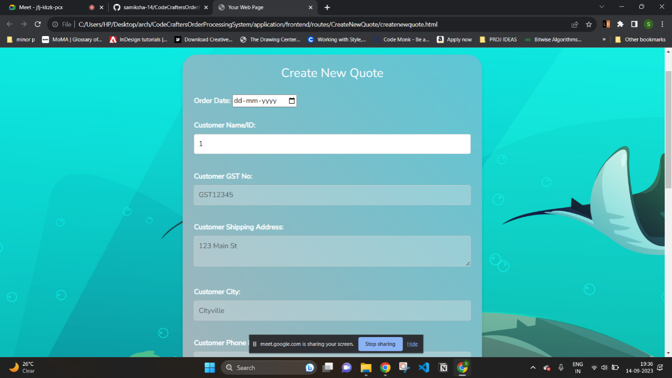

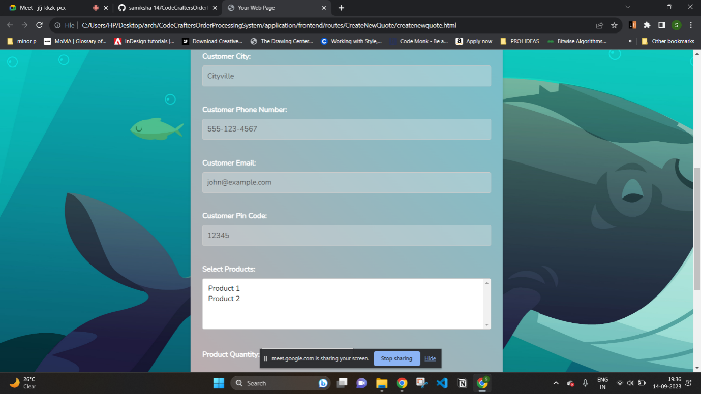

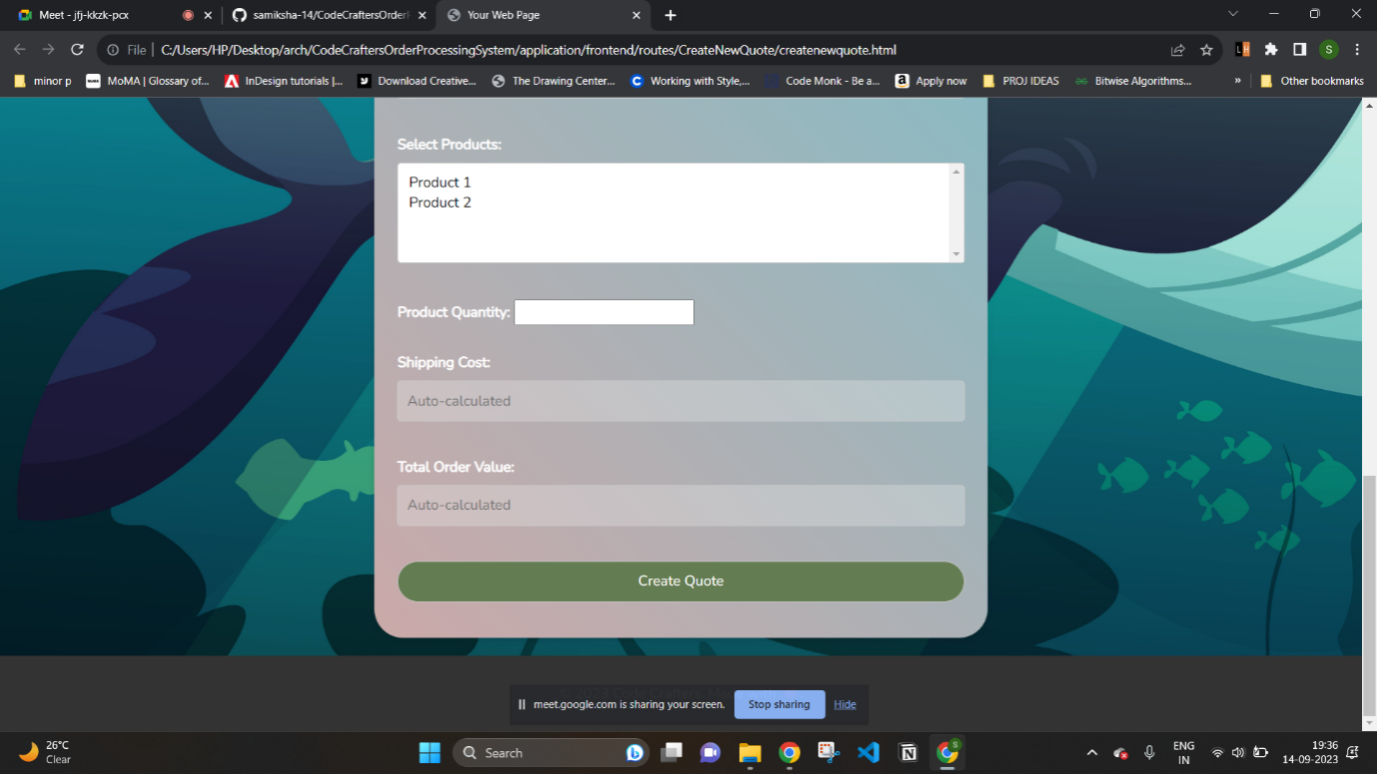

The page Create New Quote allows you to create new quote. Quotes are the orders with pending status. The page contains following fields:

Order date, Customer Name, Customer GST Number, Customer Shipping Address, Customer City, Phone Number, Email, Customer Pincode, Select Product, Product Quantity, Shipping Cost, Total Order Value and a button “Create Quote”.

**IMPORT PRODUCTS**

This page provides a user interface that allows to choose a JSON or XML file and upload it to the server by clicking on upload button.

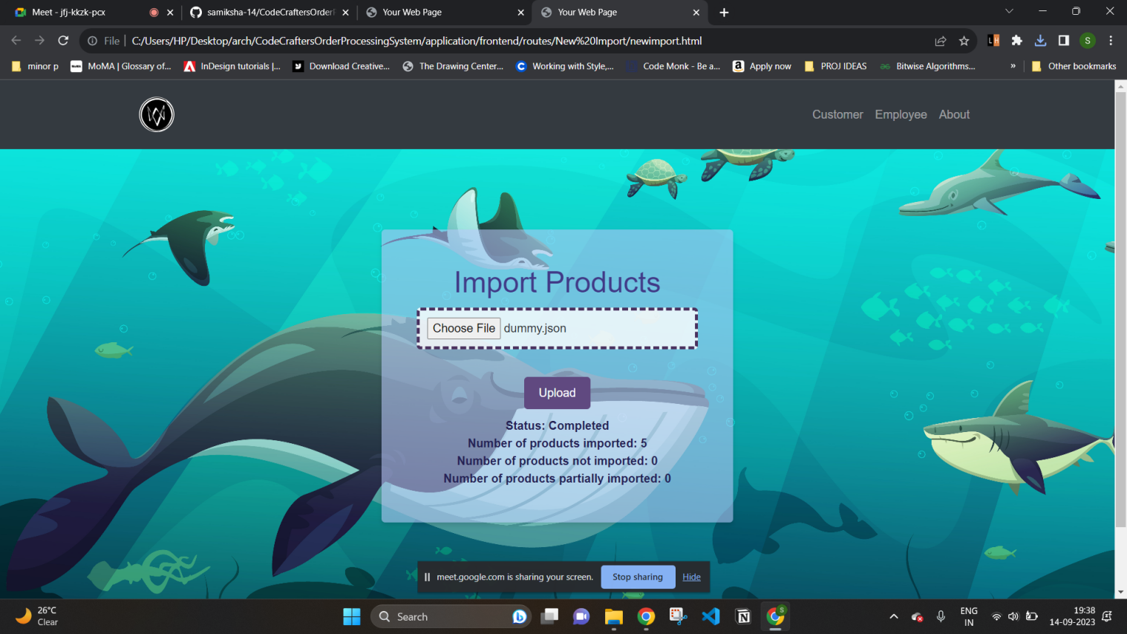

This page also provides details like status, Number of products imported, Number of products not imported and umber of products partially imported.

The page contains list of products where each product has product ID, name and category(Level-1, Level-2).

**CUSTOMER LOGIN PAGE**

Customer Login Page allows customer to login to the system. It contains a form that asks the customer to enter Customer ID, Password. On successful login the customer is directed to Order Management Page.

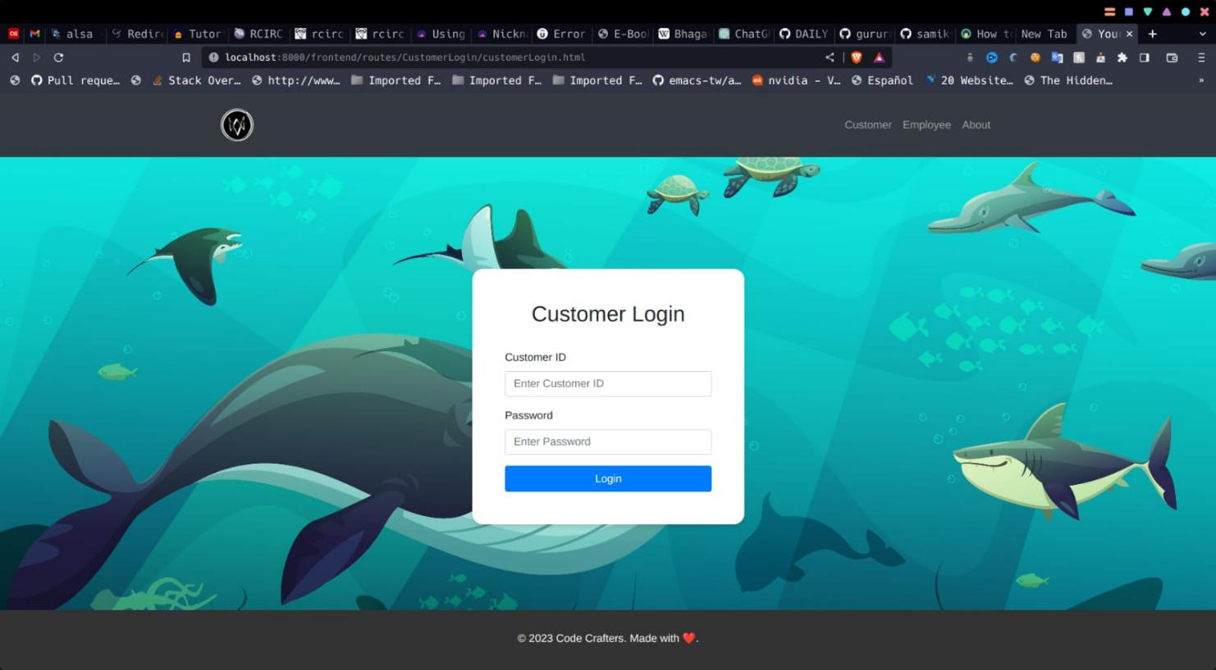

Once the customer is delegated to Order Management Page, they can view and approve quotes. The orders and invoice are also displayed.

The Order Management Page allows customer view and approve quotes. Also orders and invoices are displayed. List of quotes that are pending for approval shows Order ID, shipping cost, total order value of each item. Each item has Approve action button. List of Orders shows Order ID, shipping cost, total order value and status. Each item has a SHOW INVOICE button. The Order Management Page in respect to the customer contains two action buttons

1. APPROVE ACTION

On clicking approve action button, the quote is converted to an order.

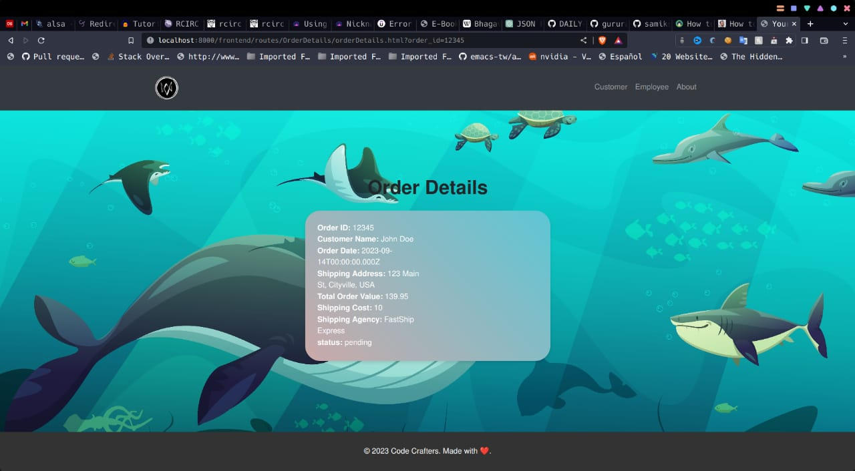

1. SHOW INVOICE BUTTON

On clicking this action button, the invoice screen of that particular item is displayed.

The invoice of a product is displayed on clicking show invoice button. The “Invoice Generation System” is the task that runs in the background to generate an invoice. Invoices are generated on a daily bases and generated only for the products approved. And this process calculates GST of product at the rate of 10% of the order value.

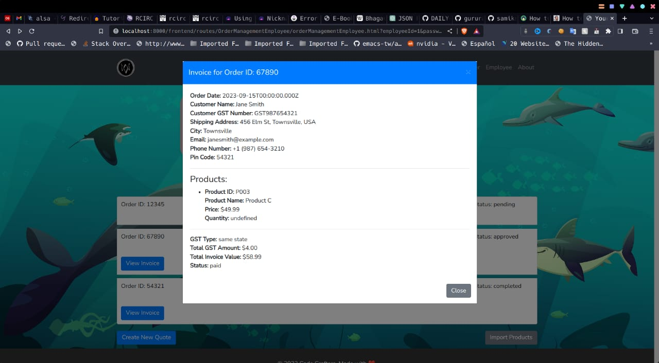

**BACK-END FLOW REPRESENTATION**

Backend implementation is also known as server-side development, is a critical part of building web applications and software systems. It focuses on the server-side logic and functionality that powers the application, handles data processing, and manages interactions between the client (front-end) and the database.

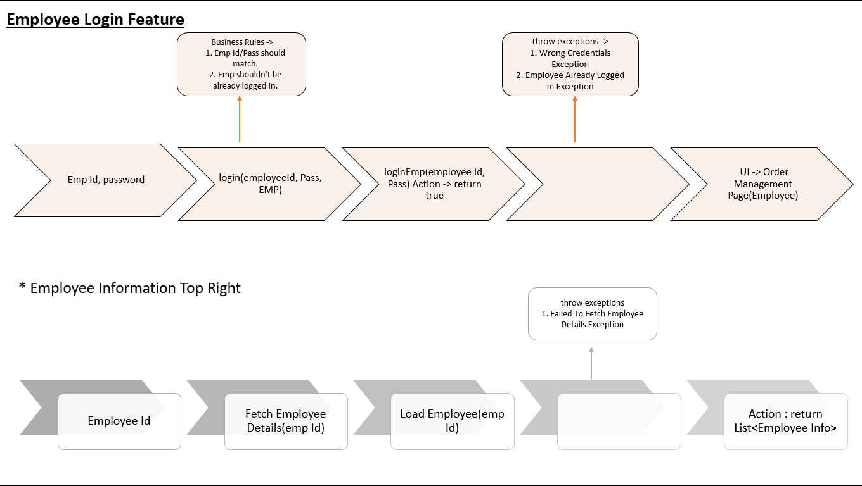

In the process of Backend implementation, there are multiple modules developed. Each module adds its own feature to the application. Modules being used are:

**utils Module**

This module contains two classes.

ShippingCalculator : This class contains java code that calculates the shipping cost based on product id and level.

* If the order value is greater than 1,00,000 irrespective of product level, there is no shipping cost.
* If the order value is less than 1,00,000

Level-1 products shipping cost is 5% of product price.

Level-2 products shipping cost is 3% of product price.

Level-3 products shipping cost is 2% of product price.

Total shipping cost is the sum.

TotalOrderValueCalculator : This class calculates the total cost of the product.

**database**

This module contains DataSourceConnectionFactory that helps in database connection.

**exception**

This package contains multiple classes that handles multiple exceptions like CustomerNotFoundException, EmployeeNotFoundException, WrongCredentialsException etc..

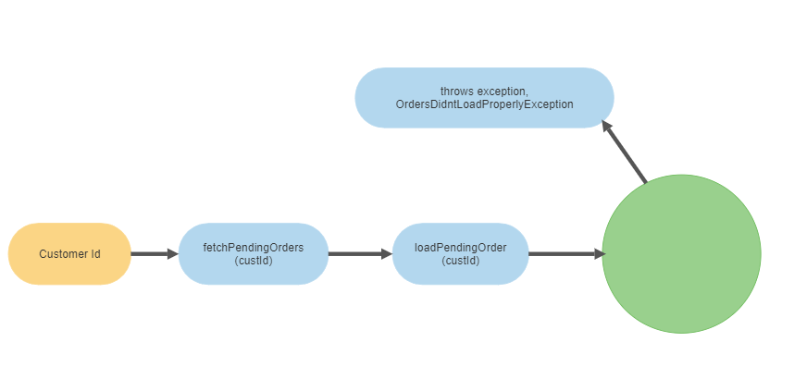

**service**

The application is a three layered architecture that ha front-end, back-end and a server which acts as intermediate between front-end and back-end. Here service package acts as a mediator. This package contains multiple abstract class java files. This package ensures security.

**repository**

This package contains multiple classes that are interfaces. Implementation of Interfaces ensure loose coupling. That makes code modification and extension easier in future

**model**

This package contains multiple classes that fetch employee, customer, product, invoice, order status details from database

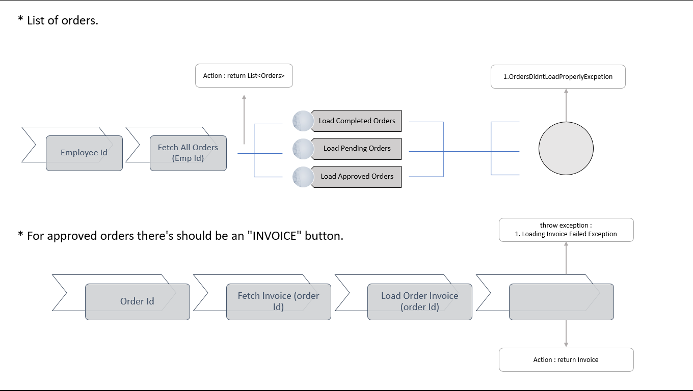

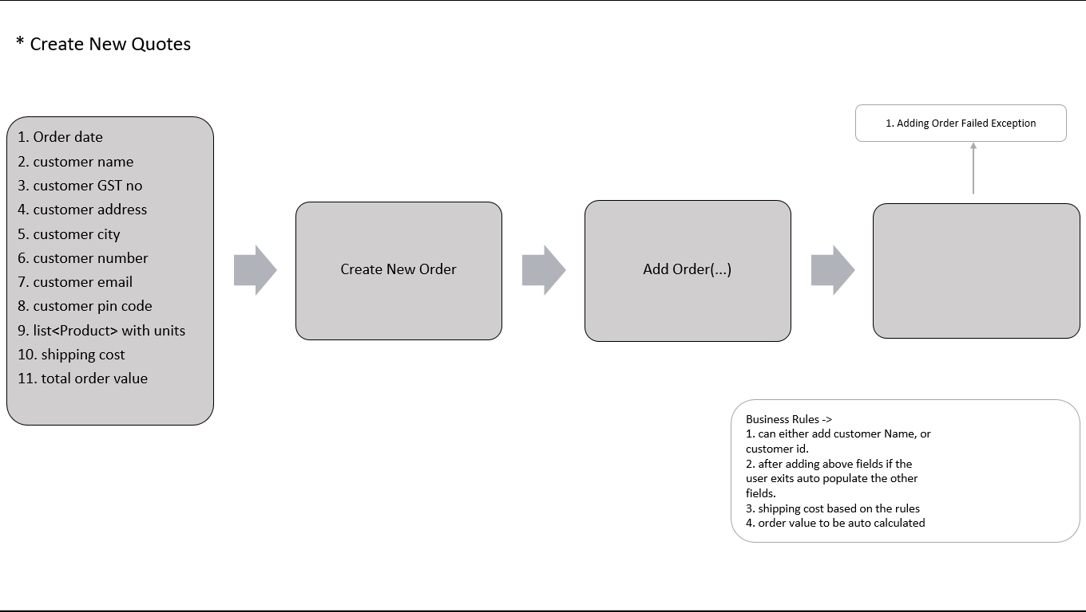

**TECHNOLOGIES USED**

**HTML:**

HTML, or HyperText Markup Language, is the standard markup language used to create web pages. It's a fundamental technology for building and structuring the content of web pages. HTML works in conjunction with other web technologies, such as CSS (Cascading Style Sheets) and JavaScript, to create visually appealing and interactive websites. To create a web page using HTML, you would typically write HTML code using a text editor or an integrated development environment (IDE) and save the file with the ".html" extension. You can then view the web page in a web browser to see how it's rendered. HTML serves as the foundation for web development and is essential for anyone looking to build websites or web applications.

**CSS**

CSS, or Cascading Style Sheets, is a stylesheet language used in web development to control the presentation and visual styling of HTML and XML documents. CSS allows web designers and developers to define how the elements of a web page should be displayed, including their layout, colors, fonts, and other visual attributes. CSS is an integral part of web development, allowing developers to transform HTML content into visually appealing and user-friendly web pages. It plays a crucial role in the overall user experience and is an essential skill for web designers and developers.

**JAVASCRIPT**

JavaScript is a versatile and widely used programming language primarily known for its role in web development. It allows you to add interactivity, dynamic behavior, and client-side scripting to web pages. JavaScript is executed in web browsers, making it a crucial component of modern web applications. JavaScript is an essential tool for front-end web development, allowing developers to create interactive and responsive user interfaces. It also plays a role in back-end development with technologies like Node.js. Understanding JavaScript is fundamental for web developers looking to build modern web applications.

**JDBC**

JDBC, or Java Database Connectivity, is a Java-based technology and API that allowsjava applications to interact with relational databases. JDBC enables developers to connect to databases, send SQL queries, retrieve and manipulate data, and manage database transactions. JDBC is a crucial technology for Java developers working with relational databases. It provides the necessary tools and abstractions to create robust, database-driven applications while adhering to best practices for database interaction and security. Additionally, many higher-level Java persistence frameworks and ORM (Object-Relational Mapping) tools, such as Hibernate and JPA, build upon JDBC to simplify database operations and further enhance developer productivity.

**SQL**

SQL, or Structured Query Language, is a domain-specific language used for managing and manipulating relational databases. SQL is the standard language for interacting with relational database management systems (RDBMS) like MySQL, PostgreSQL, Oracle, SQL Server, and SQLite. SQL is a critical skill for database administrators, data analysts, and software developers who work with relational databases. It provides a powerful and standardized way to interact with and manage data, making it an essential tool in the world of data management and application development.

**RESULTS**

The implementation of the Order Processing System has yielded several significant outcomes, positively impacting various aspects of our business operations. The designed system application resulted a functional front-end and reactive back-end. We are able to design the application that follows solid principles I.e., the application is very evident, open for addition and closed for modification. We ensured that system is developed in a way, that code is loosely coupled. Therefore, it is very easy to add extra features in future without making much changes in the code. The automated order processing system has led to a notable reduction in order processing times. Resulting in quicker order fulfillment and improved customer.

**CONCLUSION**

In conclusion, an Order Processing System automates many manual tasks, reducing the need for human intervention. This efficiency improvement results in faster order processing and reduced operational costs. The System is a web application that is user-friendly and easy to use. An Order Processing System is a fundamental component for businesses involved in sales and distribution. It streamlines the order-to-delivery process, enhances customer satisfaction, and contributes to the overall success and growth of the organization.

The implementation of the Order Processing System represents a significant milestone in our organization's pursuit of operational excellence and customer-centricity. This comprehensive system, designed to automate and optimize the order-to-delivery process, has yielded substantial benefits and has proven to be a strategic asset for our business. As we look to the future, we recognize the potential for further enhancements and the integration of emerging technologies to further optimize our order processing capabilities. The Order Processing System will continue to play a central role in our growth strategy, enabling us to adapt and thrive in a dynamic business environment. In summary, the Order Processing System has not only improved our internal operations but also reinforced our ability to deliver exceptional service to our customers. It is a testament to our dedication to innovation and efficiency, and we are excited about the possibilities it unlocks for our organization as we continue to evolve and grow.